NAME: MUHAMMAD AHSAN NAEEM
ROLL: F2024332104
SEC: D1
LAB 3:
LAB TASKS;
CREATE USER 1:
sudo adduser ahsan
this command is used to create new user and sudo is give permission in linux
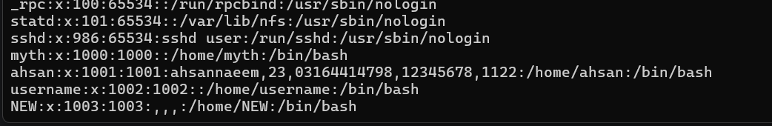
UPDATE AN EXSITING USER 2:
sudo passwd NEW
we shift to new user from old user
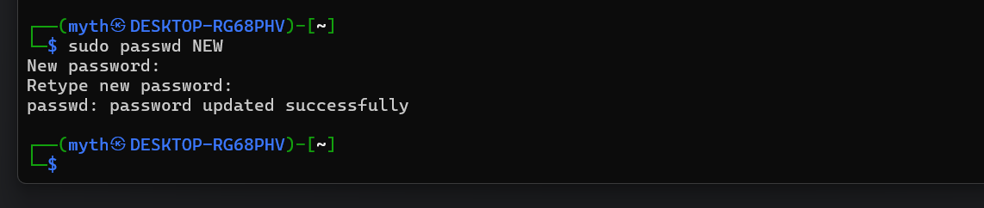
Open linux in TASK MANAGER: 3:
Top
We use this to open task manager
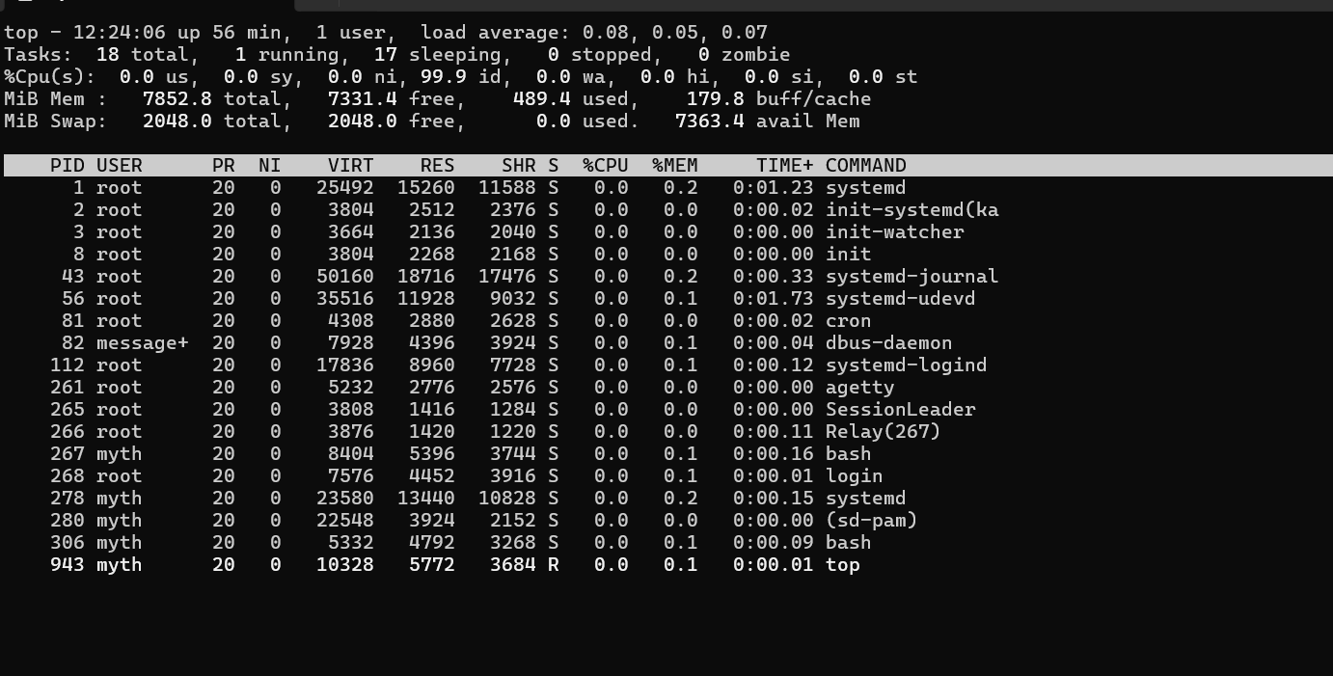
KILL THE PROCESS: 4:
kill process_number 943
